Tutorial 13 – Python + Selenium Environment Configuration
Screenshot Report
Field | Details
Website / Tool | Selenium Web Form
URL | https://www.selenium.dev/selenium/web/web-form.html
Module | Environment setup
Student Task | Verify the Python + Selenium setup with 5 checks (SET01-SET05) and capture the 6 required screenshots.
Test Cases | Same TC IDs as the test case sheet: SET01 to SET05
Tester Name | Tester: Kothari Mann Jitendrakumar
Enrollment No | 2504030100433
Environment | Windows 10/11, Google Chrome (latest), internet connection

Note: How to run: save the matching script from the scripts folder, run it in VS Code, then for EACH test case take (1) a screenshot of that test case's code and (2) a screenshot of the browser while it runs. The scripts were written from the sites' standard page structure and syntax-checked, but I could not run them against the live sites. If one fails with 'NoSuchElement' / 'Timeout', tell me the message. Script: t13_setup_seleniumwebform.py. The terminal commands for SET01/SET02 are: python --version and pip show selenium.

Test Case Execution

SET01 – Verify Python installation
TC ID | SET01
Test Case | Verify Python installation
Test Data | Command: python --version
Expected Result | Python version (3.x) is displayed
Actual Result | Python 3.x version displayed
Status | PASS
Screenshot | 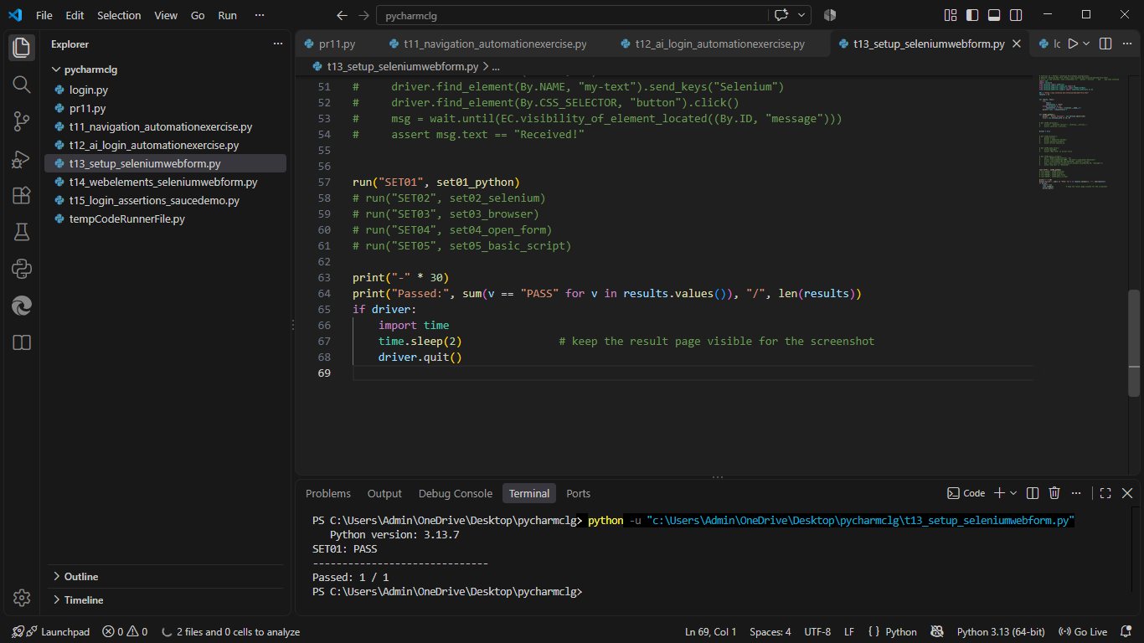
Defect ID | N/A

SET02 – Verify Selenium installation
TC ID | SET02
Test Case | Verify Selenium installation
Test Data | Command: pip show selenium
Expected Result | Selenium name and version are displayed
Actual Result | Selenium details displayed
Status | PASS
Screenshot | 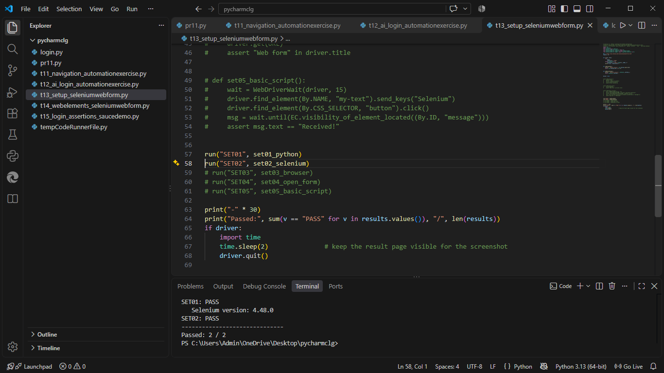
Defect ID | N/A

SET03 – Verify the browser launches
TC ID | SET03
Test Case | Verify the browser launches
Test Data | Browser: Chrome
Expected Result | Chrome opens (automation banner shown)
Actual Result | Chrome window opened
Status | PASS
Screenshot | 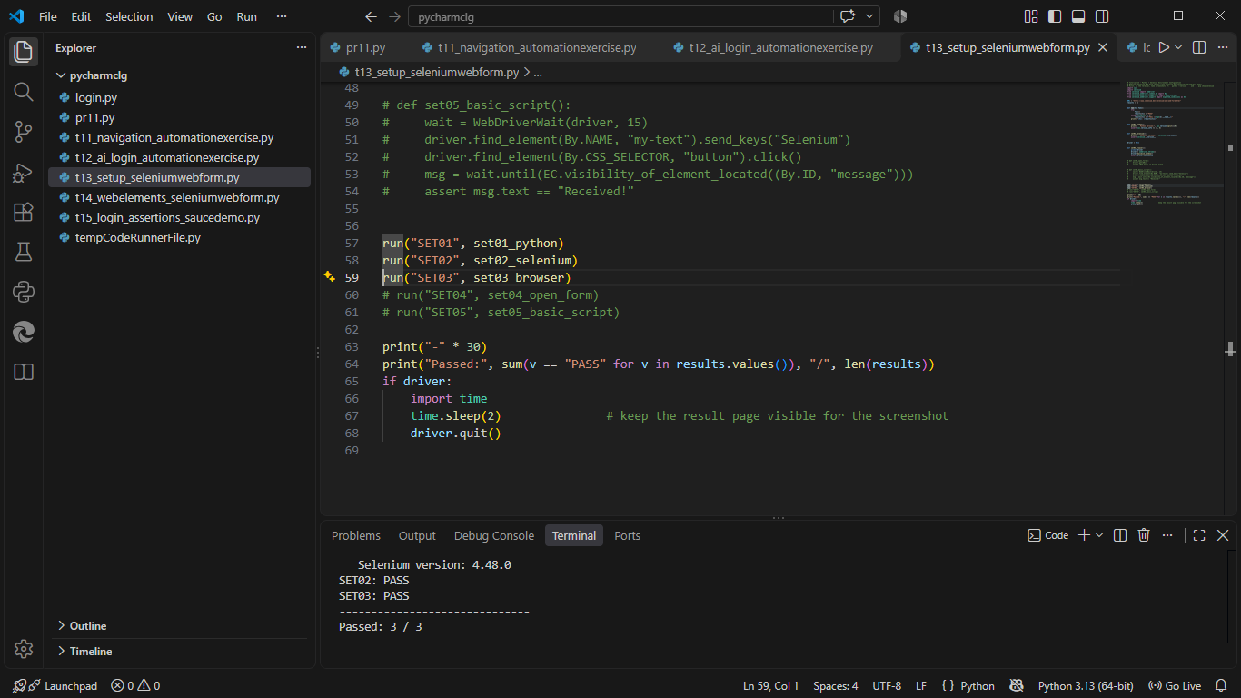
Defect ID | N/A

SET04 – Verify the Selenium Web Form opens
TC ID | SET04
Test Case | Verify the Selenium Web Form opens
Test Data | URL: https://www.selenium.dev/selenium/web/web-form.html
Expected Result | Web form page opens with title 'Web form'
Actual Result | 'Web form' page opened
Status | PASS
Screenshot | 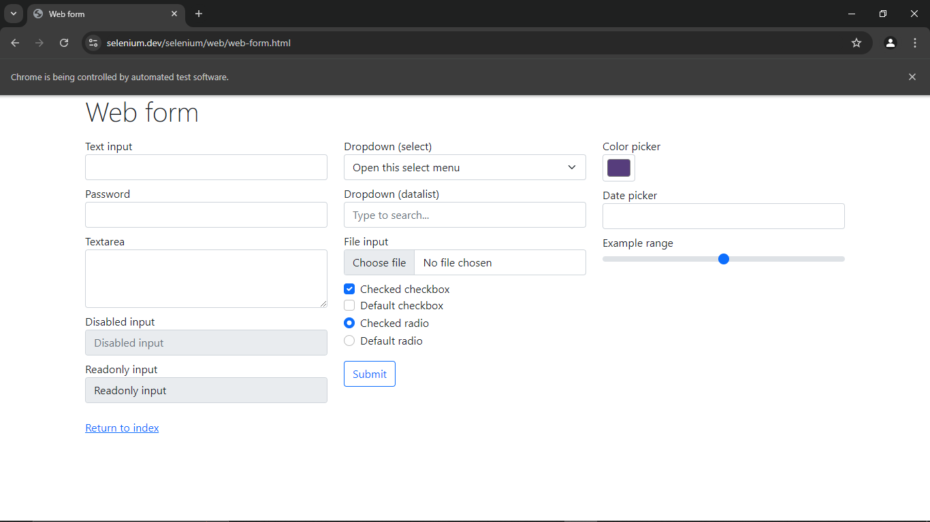
Defect ID | N/A

SET05 – Verify a basic Selenium script executes
TC ID | SET05
Test Case | Verify a basic Selenium script executes
Test Data | Text: Selenium
Expected Result | 'Form submitted' page shows the message 'Received!'; script prints PASS
Actual Result | 'Form submitted' page opened; message 'Received!'
Status | PASS
Screenshot | 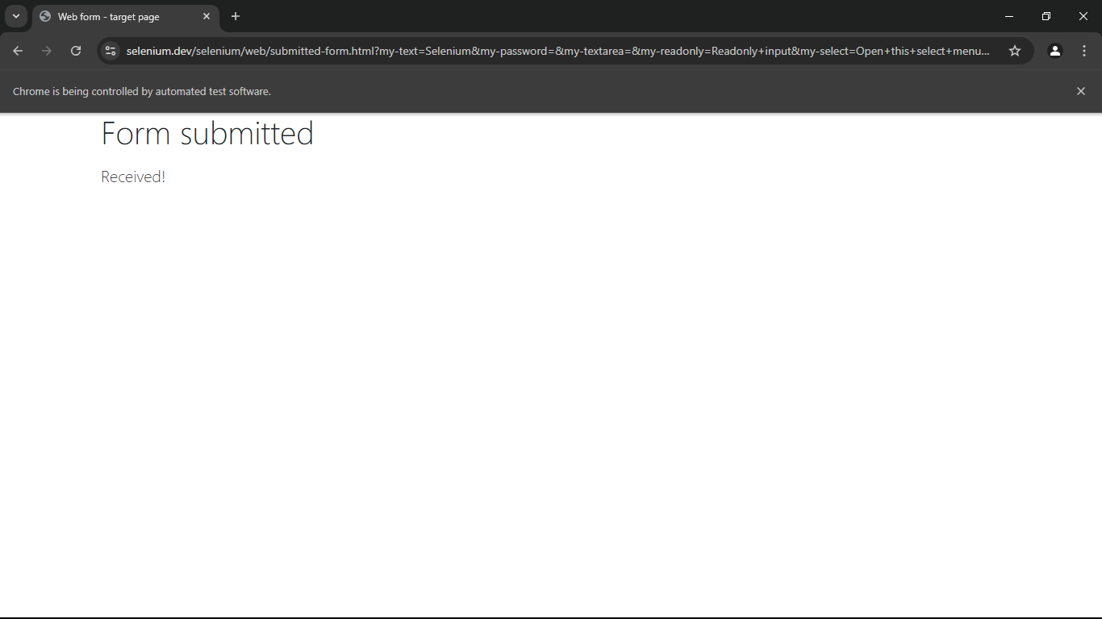
Defect ID | N/A

Setup commands (Windows)
Step | Command / Action
Check Python | python --version
Install Selenium | pip install selenium
Verify Selenium | pip show selenium
Run the script | python t13_setup_seleniumwebform.py
Driver | Selenium 4.6+ downloads the Chrome driver automatically

Test Execution Summary
Metric | Value
Total Test Cases | 5
Passed | 5
Failed | 0
Blocked | 0
Not executed yet (fill after running) | 0
Pass % | 100.0%

